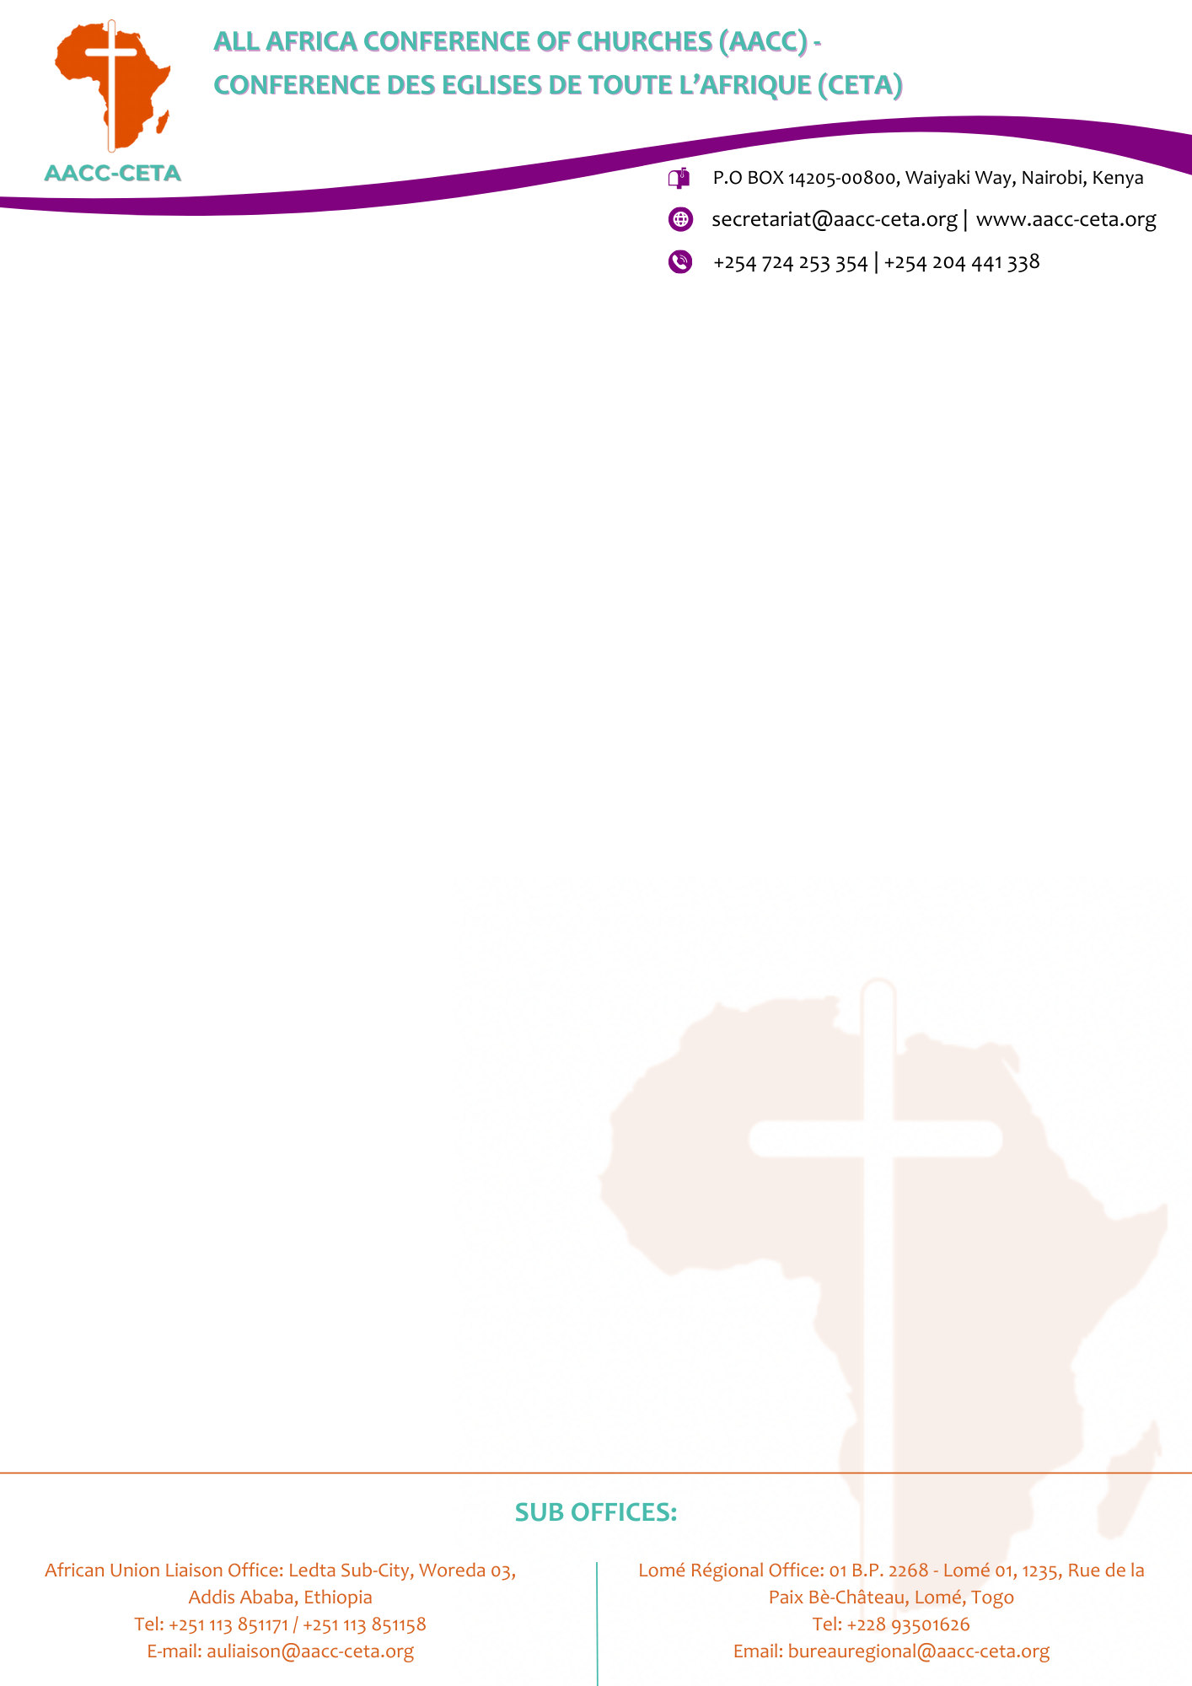

ALL AFRICA CONFERENCE OF CHURCHES (AACC) VACANCY ANNOUNCEMENT

POSITION: AUDIO VISUAL TECHNICIAN

REPORTING TO: GENERAL MANAGER
BACKGROUND
The AACC is a fellowship of 217 Member Churches and Christian Councils in 43 African countries. The organization has its Secretariat in Nairobi, Kenya, a Regional Office in Lome, Togo and a Liaison Office to the African Union in Addis Ababa, Ethiopia.
The organization has a 100- room hotel with state of the art conference rooms, and gym. Management is looking for a self-motivated Audio-Visual Technician to support in the efficient running of the hotel.

JOB SUMMARY
We are seeking a competent, hands-on and service-oriented Audio-Visual Technician to join our pre-opening hotel team. The successful candidate will support the installation, testing, commissioning and ongoing operation of the hotel's IT and Audio-Visual systems.
The position will provide technical support to hotel departments, meeting and conference facilities, guest-facing technology and hotel events, ensuring that all systems are reliable and operational ahead of opening.
Responsibilities
- Install and maintain audio visual equipment including display devices, projectors, televisions, camera systems, video teleconferencing systems (VTC), microphones and speakers.
- Perform inventory management of equipment, wirings, and accessories to avoid any shortages.
- Setup and operate audio visual equipment for trainings, presentations, meetings and conferences.
- Perform equipment additions, removals, repairs, replacements and inspections.
- Identify and resolve equipment malfunctions.
- Assemble and disassemble audio visual equipment as needed.
- Test equipment to ensure they are in good and safe working conditions.
- Maintain the work room and store room clean, safe and organized.
- Ensure setup and put away of A/V equipment is completed for all events.
- Clean and maintain equipment, report damages to the hotel general manager.
- Assist in weekly/Monthly inventory of A/V equipment.
- Keep custody of all A/V equipment room keys including equipment removal and storage.
- Basic IT Troubleshooting Skills: Demonstrate basic troubleshooting and first-level support skills for hotel technology, including computer and printer hardware, network connectivity, telephone extensions/PABX, TVs, Wi-Fi, and other guest-facing hotel technology, with the ability to identify common faults and escalate complex technical issues to the ICT/IT team or service provider
- Follow hotel policies relating to data protection, cybersecurity and confidentiality.
- Perform any other duties that may be assigned from time to time.

QUALIFICATIONS & EXPERIENCE
- Diploma or Degree in Information Technology, Computer Science, Electronics, Audio-Visual Technology, Telecommunications or a related field.
- 2–3 years' relevant experience in IT, AV, hospitality technology or events.
- Previous hotel experience is an advantage.
- Experience supporting meetings, conferences and events is highly desirable.
- Knowledge of hotel PMS/POS systems is an added advantage.
WORK STATION: AACC Desmond Tutu Conference Centre / Hotel, Nairobi - Kenya.
START DATE: 1ST OCTOBER, 2026.
DURATION OF EMPLOYMENT: One (1) year renewable based on satisfactory performance
APPLICATION:
- Applications should be accompanied by:
  - A Cover Letter.
  - Detailed Curriculum Vitae including Names and Addresses of 3 (three) referees.
  - Certified copies of all qualifications.
  - Filled Job Application Form.
- Interested candidates who meet the above criteria should send their applications to:
THE GENERAL SECRETARY
ALL AFRICA CONFERENCE OF CHURCHES
P.O BOX 14205 – 00800 WESTLANDS, NAIROBI KENYA
Or email to: hr-applications@aacc-ceta.org
SUBMISSION:
The deadline for submission is on 21st September, 2026. Only short-listed applicants meeting the above requirements will be contacted.

